

**Twenty years of inflation targeting**

Speech given by

Mervyn King, Governor of the Bank of England

The Stamp Memorial Lecture, London School of Economics 9 October 2012

I am indebted to my colleagues in the Bank and on the Monetary Policy Committee for invaluable help and insightful comments on earlier drafts of this lecture, especially to David Aikman, Charles Bean, Nils Blythe, Alex Brazier, Spencer Dale, Iain de Weymarn, Richard Harrison, Andrew Hauser,

David Miles and Tony Yates. In particular, I regard Tim Taylor as a co-author of the lecture, although he is absolved of any errors in the current draft.

All speeches are available online at [www.bankofengland.co.uk/publications/Pages/speeches/default.aspx](http://www.bankofengland.co.uk/publications/Pages/speeches/default.aspx)

## Introduction

I am delighted to be back at the School to deliver the Stamp Memorial Lecture. Lord Stamp was eminent in the worlds of both academic and public life. Among other achievements, he was an alumnus and a governor of the School, and a Director of the Bank of England. Following his untimely death, in an air raid in 1941, he was succeeded at the Bank by John Maynard Keynes. Keynes and Stamp often broadcast live discussions on the BBC which were published a week later in *The Listener*. Their conversations during the 1930s, at the height of the Great Depression, are eerily reminiscent of the enormous challenges we face today, as you can see from the following exchange in 1930:

KEYNES: Is not the mere existence of general unemployment for any length of time an absurdity, a confession of failure, and a hopeless and inexcusable breakdown of the economic machine?

STAMP: Your language is rather violent. You would not expect to put an earthquake tidy in a few minutes, would you? I object to the view that it is a confession of failure if you cannot put a complicated machine right all at once.

KEYNES: In my opinion the return to the gold standard in the way we did it set our currency system an almost impossible task ... If prices outside this country had been going up since 1925 that would have done something to balance the effect on this country of the return to the gold standard.

STAMP: Hush, Maynard; I cannot bear it. Remember, I am a Director of the Bank of England.

In some respects our experience today is no different: putting right our economic machine is proving a slow and difficult task. But in the 1920s the Government made the task substantially harder by reinstating the gold standard at a rate that left sterling overvalued. Today, monetary policy is part of the solution, not part of the problem. That is thanks, in large part, to the monetary framework we have had in place since 1992.

Twenty years ago today, on 9 October 1992, the newspapers reported that for the first time monetary policy in Britain would be based on an explicit target for inflation. Three weeks earlier, sterling had been forced out of the European Exchange Rate Mechanism (ERM). A new framework for monetary policy was needed.

After keen debates within the Treasury and the Bank of England, the answer emerged – the inflation target. The essence of this new approach was the combination of a numerical target for inflation in the medium term and the flexibility to respond to shocks to the economy in the short run – and so the framework became known as flexible inflation targeting.

It is time to reflect on twenty years’ experience of inflation targeting; fifteen years of stability and five years of turbulence – the Great Stability and the Great Recession, shown in Table 1 and Charts 1-3. Over that

period, monetary policy around the world has changed radically. Inflation targeting has spread to more than 30 countries. And the results in terms of low and stable inflation have been impressive. There have been pronounced reductions in the mean, variance and persistence of inflation in Britain and elsewhere. During the past twenty years, annual consumer price inflation in this country has averaged 2.1%, remarkably close to the 2% target and well below the averages of over 12% a year in the 1970s and nearly 6% a year in the 1980s.1

But did we pay too high a price for this achievement in lowering inflation? After fifteen years of apparent success, the past five years of financial crisis and turmoil in the world economy have raised serious questions about the adequacy of inflation targeting. We don’t have to look far to see that the costs of financial instability are huge. In Britain, total output is today some 15% below an extrapolation of its

pre-crisis trend, and that gap is likely to persist for some time yet.2 In the light of such costs, should monetary policy go beyond targeting price stability and also target financial stability? And should the present financial crisis lead us to question the intellectual basis of monetary policy as practised in most of the industrialised world today? Those questions are the subject of tonight’s lecture.

## The story of inflation targeting

But let us start at the beginning. Shortly after the adoption of inflation targeting, my predecessor but one, Lord Kingsdown (Robin Leigh-Pemberton as he then was), gave an important speech at the London School of Economics – indeed in this room – entitled “The Case for Price Stability”.3 I remember it vividly – for I had been involved in drafting it. It was an exciting time; we were reconstructing British monetary policy after the trauma of forced exit from the ERM. In those days, of course, the Chancellor set monetary policy and the Bank of England played only a behind the scenes role. But the role of the Bank was about to change – first with the *Inflation Report* in February 1993, which gave the Bank its own public voice, and then with independence for the Bank and the creation of the Monetary Policy Committee (MPC) in 1997.

The inflation target was born out of the experience that high and variable inflation was very costly to reduce and that only a policy based on domestic considerations would be credible. The objective of monetary policy in the medium term would unambiguously be price stability. As the then Chancellor of the Exchequer, Norman Lamont, put it “we wish to reduce inflation to the point where expected changes in the average price level are small enough and gradual enough that they do not materially affect business and household financial plans”. The idea that there is a long-run trade-off between price stability and employment had long since been abandoned. That intellectual revolution, associated with the names of Friedman, Phelps and Lucas, had stood the test of time and formed the foundations of inflation targeting.

The initial reception of the inflation target among economists and commentators alike was distinctly mixed. As the *Financial Times* put it in a leader published twenty years ago today, “the Chancellor's speech was as

economically thin as it was politically disappointing”. The critics argued that the new framework was inadequate to control inflation. They were to be proved wrong. Over the previous twenty years inflation had been the single biggest problem facing the UK economy, peaking at 27% a year in 1975. Over the subsequent twenty years, inflation, as I mentioned earlier, would average only 2.1%.

From the outset, inflation targeting was conceived as a means by which central banks could improve the credibility and predictability of monetary policy. The overriding concern was not to eliminate fluctuations in consumer price inflation from year to year, but to reduce the degree of uncertainty over the price level in the long run because it is from that unpredictability that the real costs of inflation stem.

The improvement in credibility of policy is shown by the fact that whereas in 1992 expected inflation, as measured by the difference between yields on conventional and index-linked gilts, was close to 6%, today the same measure is around 2½ %.

Predictability of the price level is greater because over a long period inflation has on average been close to the target.4 Even if inflation deviates from target – as will often be the case – it is expected to return to target, and so inflation expectations are anchored.5 That is why since 2007 the UK has been able to absorb the largest depreciation of sterling since the Second World War, as well as very large rises in oil and commodity prices, with an increase in inflation to an average of only 3.2% over the past five years and without dislodging long-term inflation expectations. So the framework has been tested and has proved its worth.

But the current crisis has demonstrated vividly that price stability is not sufficient for economic stability more generally. Low and stable inflation did not prevent a banking crisis. Did the single-minded pursuit of consumer price stability allow a disaster to unfold? Would it have been better to accept sustained periods of below or above target inflation in order to prevent the build up of imbalances in the financial system? Is there, in other words, sometimes a trade-off between price stability and financial stability?6

## The intellectual foundations of monetary policy

The experience of the past five years suggests that we reassess the intellectual framework underpinning monetary policy.7 The emergence of inflation targeting, and the successful results in the form of the Great Stability, coincided with the development of the so-called New Keynesian consensus on macroeconomic theory. This framework offered a theoretical foundation for flexible inflation targeting. Central to the New Keynesian view is the assumption that some prices are “sticky” and adjust slowly. That assumption has two implications. First, high inflation produces inefficient changes in relative prices. As a result, there is a cost to inflation. Second, when central banks change nominal interest rates they also affect real interest rates, and so encourage households and businesses to switch expenditure from today to tomorrow or, as in present

circumstances, the other way round. In this way, central banks can, in the model at least, offset shocks to aggregate demand.

But there are shocks to supply as well as demand. External cost shocks sometimes drive inflation away from the target, as we saw in recent years with rises in world energy and food prices. Because other prices are “sticky”, attempts to keep inflation at target all the time would result in inefficient fluctuations in output. There is, therefore, a trade-off between stabilising inflation and stabilising output. Following a cost shock, it is sensible to bring inflation back to target gradually.

In this, by now conventional, framework, the proper objective of monetary policy is to minimise the variability of inflation around the target rate and the variability of output (or employment) around a sustainable path consistent with stable inflation.8 Such an objective means that the central bank is effectively choosing a trade-off between the volatility of inflation and the volatility of output. This is sometimes described as choosing a point on the Taylor frontier showing, as in Chart 4, the combinations of lowest volatility of inflation for a given volatility of output.9 That optimal choice leads to a policy reaction function describing how the central bank responds to shocks hitting the economy.10

The success of the New Keynesian framework was that it showed how the long run objective of price stability could be implemented by an appropriate central bank policy reaction function. It stressed the importance of expectations and credibility, to which too little attention had been paid during the inflationary episodes of the 1970s and 1980s.

But inevitably, as with all models, the basic New Keynesian model omits a number of key factors. The treatment of expectations is simplified, and neglects the possibility that expectations themselves may be a source of fluctuations, rather than simply reflecting changes elsewhere in the economy. Sentiment can vary, misperceptions occur, and people can change the heuristics they use to cope with a complex world.11 And it lacks an account of financial intermediation, so money, credit and banking play no meaningful role. Those omissions obviously limit the ability of the model to help us understand the trade-offs between monetary policy and financial stability.

Although there is a, by now extensive, literature on financial frictions, including attempts to incorporate them in New Keynesian models, it turns out that such extensions make little difference to the propagation of shocks, to optimal policy, or to the quantitative conclusion that overwhelmingly the most important objective remains inflation stabilisation.12 There is no doubt that financial frictions such as asymmetric information, credit constraints, and costly monitoring of borrowers, to name but a few, are an important part of the story of how crises happen and why they impact on output. But those models do not provide a convincing account of the gradual build-up of debt, leverage and fragility that characterises the run-up to financial crises.13

Existing models, then, do not tell us why stability today may come at the expense of instability tomorrow. Perhaps we should heed the advice of Ricardo Caballero, who has written that “macroeconomic research has been in ‘fine-tuning’ mode within the local maximum of the dynamic stochastic general equilibrium world, when we should be in ‘broad-exploration’ mode”.14

So let me now move into broad exploration mode and give **three** examples in which a trade-off between monetary and financial stability might arise, and which could in theory justify a policy of aiming off the inflation target in order to reduce the risk of future financial instability, before I turn to whether such a policy would have been appropriate before the crisis.

The **first** is where misperceptions about future incomes persist and are embodied in key prices, such as the exchange rate and long-term interest rates. Households, businesses, and banks can all make big mistakes when forming judgements about the future, and make spending decisions today which they will come to regret when their true lifetime budget constraints are revealed. There is no mechanism for ensuring that misperceptions about the sustainable level of spending are corrected quickly. It may take many years before those beliefs are invalidated by experience. So an equilibrium pattern of spending and saving can emerge that is stable temporarily but not sustainable indefinitely. And misaligned prices may reinforce mistaken beliefs if people are using market prices to extract signals about future incomes and consumption opportunities. Evidence of the persistence of misperceptions can be seen in the imbalances in the world, and especially the European, economies.

I do not mean to imply that when economic agents make these mistakes they are behaving irrationally. Rather that in a world of intrinsic uncertainty it is far from obvious how to make decisions. The assumption of rational expectations is very helpful for economists when trying to understand the implications of their own models – it is a discipline to prevent the drawing of arbitrary conclusions. In practice, however, households are on their own in a highly uncertain and complex world where they are learning from experience. When it comes to decisions about how much to spend and how much to save, expectations of future incomes are crucial. In the absence of a complete set of markets for future consumption goods – and labour – there is no mechanism to ensure that decisions today, and so the implied plans for tomorrow, will be consistent with the possibilities available in the future. If revisions to expectations of future incomes are uncorrelated across households, then aggregate spending will be relatively stable. The problem comes when many households have similarly over-optimistic views about the future. Aggregate spending and borrowing can then be unsustainably high and lead to an inevitable correction at an unpredictable date when reality dawns.

Financial markets both reflect and propagate that common degree of optimism. Sentiment and animal spirits can change very quickly.

Examples include the extrapolation of past growth rates of incomes or asset prices into the future when in fact they reflect an adjustment of the level of income or asset price to a new equilibrium. At the time, the

MPC argued that the rise in the ratio of house prices to incomes in the years leading up to 2007 reflected a fall in long-term real interest rates – in other words, an adjustment to a new equilibrium house price to income ratio. But if households extrapolated past increases in house prices into the future, then they may have mistakenly inferred that future incomes too would be higher, and so spending and borrowing more than could be sustained. Similar arguments could be made about the reaction of businesses and households to the rise in the sterling effective exchange rate in the late 1990s, and I shall return to this later.

Since long-term interest rates in financial markets are, if anything, even lower today the question of sustainability has not yet been resolved. Misperceptions mean that unsustainable levels of spending, and associated levels of debt, can build up over many years. When those misperceptions are eventually corrected, they lead to sudden large changes in asset values, a synchronised de-leveraging of balance sheets, a large downward correction to spending and output, and defaults.15 Keynesian policies to smooth the path of adjustment by supporting aggregate demand can help in the short run, but their effectiveness is limited by the fact that a significant adjustment to spending – from consumption to investment – is required.

If policymakers can, first, identify misperceptions, and, second, correct them by changes in monetary policy – both highly uncertain empirically – then there is indeed a trade-off between hitting the inflation target and reducing the chance of a financial crisis down the road. But are central banks less prone to misperceptions than others?

My **second** example concerns what Masaaki Shirakawa, Governor of the Bank of Japan calls the ‘cycle of confidence’. He argues that success breeds confidence, and eventually over-confidence and complacency, leading to collapse. Such ideas are closely associated with the work of Hyman Minsky and others. Minsky set out a ‘financial instability hypothesis’ in which a period of stability encourages exuberance in credit markets and subsequent instability.16

Perhaps the experience of unprecedented stability in the UK and world economies before the crisis dulled the senses and bred complacency about future risks. I talked about this when I christened the period leading up to 2003 the *nice* (*n*on-*i*nflationary *c*onsistently *e*xpansionary) decade.17 The point of that speech was that the following decade was unlikely to be as nice. And, of course, it wasn’t. But the point didn’t get home, and the financial system became more and more fragile as the leverage of our banking system rose to unprecedented levels. The experience of continuing stability may have sowed the seeds of its own destruction.

That idea has been explored recently in an interesting new book by Nassim Taleb.18 He argues that the opposite of fragility is not resilience or robustness, but “antifragility”, that is a state in which people or institutions thrive on volatility, shocks to the system and risk. We go to the gym to stress our muscles in order to strengthen them; occasional seismic activity may prevent a more damaging earthquake. Frequent

exposure to shocks and surprises may improve the way people learn about and manage risks. In a complex world, we are “better at doing than we are at thinking”, in Taleb’s words. Unless we train and practice at coping with bad outcomes we may fail to respond in the right way to adverse shocks when they come. “Antifragility” does not imply that it might be desirable to engineer small recessions in order to head off a deep depression. We know far too little about the economy to attempt any such strategy, and in a world of intrinsic uncertainty we rely on heuristics – simplified rules of thumb – to guide our behaviour. But it offers a warning of the dangers of believing that the role of monetary policy is to offset all shocks. Rather than pretend that we can forecast the future, a more intelligent response is to reinforce the resilience of those parts of the financial system that we cannot permit to fail and encourage entry and exit in a free market in other parts. It is clear that we need to understand more about how stability affects risk-taking, leverage, and the ‘cycle of confidence’.

My **third** example relates to the so-called ‘risk taking’ channel of monetary policy.19 Short-term policy rates, especially when they are, as now, exceptionally low, may encourage investors to take on more risk than they would otherwise wish as they ‘search for yield’.20 Financial institutions with long-term commitments (pension funds and insurance companies, for example) need to match the yield they promised on their liabilities, with the yield on their assets. When interest rates are high, they can invest in safe assets to generate the necessary revenue. When interest rates are low, however, they are forced to invest in riskier assets to continue to meet their target nominal rate of return. That tends to push down risk premia and lower the price of borrowing. Other investors too find it difficult to accept that in a world of low nominal and real interest rates equilibrium rates of return will not meet their previous expectations.21 If these mechanisms are important, the financial cycle may be heavily influenced by monetary policy, especially when interest rates are low. That also creates the possibility of a trade-off between monetary and financial stability.

All three examples suggest that the conventional analysis of the trade-off between the volatility of inflation and the volatility of output is likely to be far too optimistic. Does this add up to a case for ‘leaning against the wind’ of rising asset prices rather than waiting to ‘mop’ up after the bust? Certainly we have seen that monetary policy cannot fully offset the effects of financial crises for two reasons. First, crises may impact output before the response of monetary policy is felt. Second, crises typically reduce potential supply growth, for example by disrupting the supply of credit to productive firms. A failure to take financial instability into account creates an unduly optimistic view of where the Taylor frontier lies, especially when it is based on data drawn from a period of stability. Relative to a Taylor frontier that reflects only aggregate demand and cost shocks, the addition of financial instability shocks generates what I call the Minsky-Taylor frontier, shown in Chart 5. This reflects the influence of misperceptions, financial cycles and the search for yield. On the Minsky-Taylor curve, for a given degree of inflation variability, output is more volatile in the long run than on the simple Taylor curve. Ignoring financial instability might mean choosing a policy reaction function that is believed to imply a trade-off at point O in Chart 5. In fact, the true trade-off is given by point P. Once that

is understood then the optimal policy reaction function might well change and correspond to a trade-off at point Q.22

The examples I have given suggest the possibility that there is a trade-off between meeting the inflation target in the short run and reducing the risk of a financial crisis in the long run. To shed light on whether that possibility warrants a change to the way we implement inflation targeting, I want now to conduct a

counter-factual thought experiment and ask whether monetary policy before 2007 might have moderated the crisis if it had not simply pursued a target for inflation.

## A Counter-Factual Monetary Policy 1997-2007

I want to ask whether, with the benefit of hindsight, monetary policy should have been set differently during the period of the so-called Great Stability. Should interest rates have been higher during that period in order to mitigate some of the growth of credit, rise in asset prices, and increase in the leverage of the banking system? Many commentators today seem to think that the answer is clearly yes – though I seem to remember that fewer said so at the time – and most of the pressure on the MPC, both from without and within, was for lower rather than higher levels of Bank Rate.23

Before trying to answer the question, let me remind you of two key facts about the Great Stability. First, the growth rate of GDP over the period prior to the onset of the crisis in 2007 was 2.9%, very **close** to its previous long-run average of 2.8% (see Table 2). Second, the policy rate set by the MPC was **higher** than that in any other G7 country for almost the whole of the ten years prior to the crisis (see Chart 6).

But if the rate of growth was sustainable, its pattern was not. In the late 1990s, there had been a substantial, and not entirely explicable, rise in sterling of around 25% against most other currencies, leading to the emergence of imbalances in the UK economy. These took the form of a shift in the composition of output away from manufacturing and towards services, and a shift in demand away from exports towards domestic demand. National saving fell to unsustainably low levels.

In the early years of the MPC there was an intense debate about these imbalances, and how they should affect monetary policy.24 In a speech in April 2000, I argued that “it is important not to let domestic demand grow too rapidly for too long. The longer the correction is left, the sharper the required adjustment will be”.25 The question was how much to stimulate domestic demand, at the cost of exacerbating the imbalances, in order to compensate for weak external demand, and the minutes of the MPC in 2001 and 2002 explicitly discussed the case for accepting inflation below target over the two-year horizon.26 The Committee rejected the case, and during that period most of the dissenting votes on the MPC were for lower rates (see Table 3). The dilemma, and the MPC’s resolution of it, was summed up by my predecessor Eddie George in 2002 when he said “So in effect we have taken the view that unbalanced growth in our present situation is better

than no growth – or as some commentators have put it, a two-speed economy is better than a no-speed economy.”27

Was that the right choice?

As in some other industrialised countries, asset prices, including house prices, had been pushed up by falls in long-term real interest rates (see Chart 7). Since those long rates were set in world capital markets by the interaction between the demand for investment and the (very large) supply of saving, only a strategy of persistently higher interest rates at home than overseas – which to some extent we did follow – would have prevented a significant rise in asset prices, thus reducing some of the upward pressure on credit growth.28

Such a strategy might have brought some benefits for financial stability. It is possible that without rising asset prices we might have kept expectations of future incomes on a more modest path that did not later require a correction. Higher rates and the resulting recession and unemployment might have reminded firms, households and financial markets that the economy was not guaranteed to experience continual steady growth, and thereby have disrupted the dynamic I described earlier in which stability leads to overconfidence and eventual instability – by stressing the economy in order to promote its “antifragility”, in Taleb’s phrase. And higher domestic interest rates might have alleviated some of the ‘search for yield’ that probably followed a period of low rates.

But leverage and the growth rate of credit may be relatively insensitive to interest rates, especially once a self-reinforcing cycle of optimism and credit expansion is underway. And this financial crisis was a global one; the United Kingdom could not alone have stopped it happening. We would still have suffered greatly from the very sudden and sharp fall in world output and trade in 2008-09. We might still have experienced a banking crisis and a domestic ‘credit crunch’ because, as my colleague Ben Broadbent has described,29 lending to the UK real economy contributed only a small share of the rise in leverage of the largest UK banks which reflected more an expansion of lending within the financial sector and overseas (see Table 4). Three quarters of UK banks’ losses to date have been on their foreign assets. The search for yield that prompted excessive risk-taking was the result of low long-term interest rates around the world, not simply rates in the UK.

So what would have happened had we adopted the counter-factual policy of higher levels of Bank rate?

Of course, it is impossible to know with certainty. And much depends on what would have happened to the exchange rate. On the MPC, two views were discussed. One was that by setting interest rates at a much higher level, so dampening domestic demand and output growth, expectations of the long-run exchange rate consistent with a sustainable path of domestic demand might be dislodged and ‘jolted’ down to a lower equilibrium level – from A to B in Chart 8. Certainly, there seemed good reason at the time to imagine that

slower growth at home might mean that hot money would return to countries experiencing stronger growth. As a result, the current exchange rate would have fallen from O to P in Chart 8 and then been expected to follow the path PB consistent with uncovered interest rate parity. The result would have been higher external demand to offset weaker domestic demand. After a time, we might have attained ‘one-speed’ growth, so avoiding the unpalatable choice between ‘two-speed’ and no growth.

The other view was that higher interest rates would not have altered the expected long-run equilibrium value of sterling, but would have led to an immediate upwards jump in the exchange rate, as the greater interest rate differential with other countries would have shifted up the uncovered interest rate parity path from OA to QA in Chart 8. That would have meant even weaker external demand, and a more depressed domestic economy.30 Higher interest rates would have moderated domestic credit growth and asset prices, but only at the expense of slower output growth, rising unemployment and a prolonged undershoot of the inflation target.31

Everything would have hinged on the success of the strategy in bringing down the expected equilibrium level of sterling in the long run to avoid a further rise in sterling in the short run and a damaging recession. At best, persistently higher interest rates would have implied an initial slowing of growth, a deliberate attempt to weaken sterling, and an under-shooting of the inflation for a period. At worst, we would have seen the exchange rate appreciate further. The decade would have been characterised by rising unemployment and very low inflation.

To have deviated from our statutory remit in a direction that would have imposed real costs to output and employment would have been a big gamble. But the costs of the ensuing crisis have been so great that we cannot stop there and say that nothing could have been done.

Was there a better alternative to a strategy of higher interest rates? The natural first line of defence against financial crises is macro-prudential policy. In principle, such policies can shift the Minsky-Taylor curve closer to the original Taylor curve. With hindsight, before 2007 there should have been a cap on the leverage of banks (see Chart 9). And the cap should have tightened as asset prices increased and the likely exposure to losses increased. That is why we now have a macro-prudential policy regime in the UK. It will be overseen by the Bank of England’s Financial Policy Committee, which will have the power to direct, and make recommendations to, regulators about capital and leverage in the UK financial system.

In my judgement, the big challenge to monetary policy before the crisis was a serious mis-pricing in long-term interest and exchange rates, and the imbalances that resulted. Much of this was outside the

control of UK policy-makers and reflected developments in the world economy. It is arguable, though not certain, that in the absence of a macro-prudential regime or tighter fiscal policy, persistently higher interest rates might have been a second-best strategy. It would, though, have been a big gamble. As the Chairman

of the Federal Reserve, Ben Bernanke has remarked, “the issue is not whether central bankers should ignore possible financial imbalances – they should not – but, rather, what is ‘the right tool for the job’ to respond to such imbalances”.32 So it is vital that macro-prudential tools and micro-prudential regulation are part of the armoury of a central bank to mitigate, if not prevent, the build up of excessive leverage and

risk-taking in the banking and wider financial sector. From next year, the Bank of England will have those responsibilities, and the new Financial Policy Committee is already up and running.

But macro-prudential tools deal with symptoms rather than the underlying problems of misperceptions and mispricing. Although we think the new tools given to the Bank would have helped to alleviate the last crisis, it would be optimistic to rely solely on such tools to prevent all future crises. It would be sensible to recognise that there may be circumstances in which it is justified to aim off the inflation target for a while in order to moderate the risk of financial crises. Monetary policy cannot just ‘mop up’ after a crisis. Risks must be dealt with beforehand. I do not see this as inconsistent with inflation targeting because it is the stability of inflation over long periods, not year to year changes, which is crucial to economic success. The key principles underlying flexible inflation targeting are credibility, predictability and transparency of decision-taking, and they will remain the cornerstone of successful monetary policy in the future.

## Conclusions

Governor Leigh Pemberton’s 1992 lecture concluded with a message for the LSE: “in a world of price stability you might not think of inviting the Governor of the Bank of England to address you”. Had price stability guaranteed financial stability, and had I achieved my long-held ambition of being boring, that might have been true.

Unfortunately, it is not how things have worked out!

What I have tried to show tonight is that the case for price stability is as strong today as it was twenty years ago – both in theory and in practice. The clarity and simplicity of the inflation target helps to anchor inflation expectations on the target. We forget the lessons of the 1970s and 1980s at our peril. In the end, the essence of central banking is to maintain confidence in, and the value of, paper money.

It is far too soon to bury inflation targeting. Together with central bank independence, it played a key role in bringing price stability to the UK. As the Times reported 20 years ago, “the pound's firmer tone, and softer German money market rates, could tempt the Chancellor to shave half a point off base rates to coincide with the Prime Minister's speech at Brighton today”. The party conference season is no longer a time for speculation about changes in interest rates. No doubt we shall learn a great deal about the appropriate allocation of responsibilities to monetary policy, on the one hand, and macro-prudential policy, on the other,

over the next twenty years. But we should not throw out the baby with the bathwater. Low and stable inflation is a pre-requisite for economic success.

Much of what I have said is, I hope, a call to arms for economists, and especially younger economists, to rethink the foundations of our macroeconomic theories. Not to abandon rigorous modelling – after all, in the words of last year’s Nobel Prize winner Tom Sargent “it takes a model to beat a model” – but to recognise that in our present models the way we think of human behaviour in the face of irreducible uncertainty is seriously incomplete.

Ideas matter far more than is usually recognised in the public discussion of monetary policy which concentrates too much on personalities. Keynes and Stamp both knew that. In February 1929,

Josiah Stamp went to Paris as a member of the Young Committee to assess whether the reparations debts run up by Germany could be repaid – the similarities with the present situation in Europe are too poignant to dwell on. In a letter to Keynes, Stamp compared these international meetings to a conjuror trying to pull a rabbit out of the hat:

“It is *still* a madhouse, in a way *–* but all are mad in a very genteel way, the main occupation being elaborate proofs, from different angles, of sanity. One half sit round a hat saying with Coué reiteration: there *is* a rabbit

– there *is*. The other half try to make a noise like a succulent lettuce. There is a general conviction that the more eminent the conjurors convened, the more certainty is there of the existence of the rabbit”.33

The only escape from madness is the power of ideas. Today, we understand less than we would wish about how the economy works. The challenge of trying to understand more, and of developing those new ideas, belongs to you – the next generation of students and academics at the LSE and elsewhere. Go to it!

# Endnotes

1 The continuously compounded annual rate of inflation (as measured by the CPI) from August 1992 to August 2012 was 2.1%, and the average of the annual rates each August over that period is 2.2%.

2 Reinhart and Rogoff (2009) present an array of evidence to document the cost of prolonged recessions following financial crises.

3 Leigh-Pemberton (1992).

4 The difference between inflation and price level targeting is often exaggerated in the literature, as discussed in King (1999).

5 Since the start of the crisis, there has been a convergence between the practice of flexible inflation targeting and the practice of dual-mandate central banks. The Federal Reserve quietly adopted a 2% inflation target in January, and Japan did the same with the announcement in February of a numerical goal for inflation of 1% a year. This practical convergence means that there is now little steam behind the question of the relative merits of the two approaches to the target, or mandate, for central banks.

6 A number of commentators have questioned the wisdom of flexible inflation targeting. For example, Eichengreen et al (2011) and Barker (2012). The first of those asserts that “the traditional separation, in which monetary policy targets price stability and regulatory policies target financial stability, and the two sets of policies operate largely independently of each other, is no longer tenable” (*op. cit*. p. 5).

7 The most complete analysis of the New Keynesian model as applied to monetary policy is Woodford (2003). It is no accident that in official circles the most serious questioning of the foundations of inflation targeting emanates from the Bank of Japan (BoJ) and the Bank of International Settlements (BIS). The “lost decade” has prompted an interesting series of speeches by the BoJ’s governor, Masaaki Shirakawa. And the BIS, freed from day-to-day involvement with the setting of interest rates, has long argued that monetary policy and financial policy cannot be considered separately.

8 This specification of the objective function can be derived as an approximation to the maximisation of the welfare, defined over consumption and leisure, of a representative consumer with an infinite horizon (see Rotemberg and Woodford, 1997).

9 The frontier is named after the US economist John Taylor.

10 To implement such a policy reaction function requires an empirical judgement about the factors that drive the volatility of both inflation and output. In principle, these should include those factors in the banking and financial system, including movements in asset prices, that generate fluctuations in demand and output and affect the way in which shocks are transmitted through the economy. In practice, however, rather little attention was paid to the role of the banking system in determining inflation and output.

11 Brazier et al. (2008).

12 The relevant literature tries to integrate standard or workhorse models of financial frictions (such as the Bernanke-Gertler (1989) model of the financial accelerator and the Kiyotaki-Moore (1997) model of credit cycles) into a New Keynesian “sticky” price model. Examples of this literature include Bernanke, Gertler and Gilchrist (1999), Curdia and Woodford (2009) and Gertler and Kiyotaki (2010). The only way the addition of a financial sector ‘matters’ in these models is if we contemplate exogenous shocks to the financial friction itself. That is not very instructive. Several interesting papers presented at a Federal Reserve conference in Washington in March 2012 analysed a wide variety of potential “financial frictions” that might create externalities that would justify a policy intervention. My concern is that there seems no limit to the ingenuity of economists to identify such market failures, but no one of these frictions seems large enough to play a part

in a macroeconomic model of financial stability. So it is not surprising that it has proved hard to find examples of frictions that generate quantitatively interesting trade-offs between price and financial stability – the finding in these models is that overwhelmingly the most important objective remains stabilisation of inflation.

13 Focussing on small deviations around the linearization of the steady-state of a dynamic stochastic general equilibrium model helped to divert attention away from the gradual build up of big risks.

14 Caballero (2010).

15 There is a substantial literature on debt deflation, including Fisher (1933), Minsky (1982b), Bernanke and Gertler (1990), King (1993), Eggertsson and Krugman (2012).

16 Minsky (1982a). More recently Geanakoplos (2010) has set out a theory of what he calls the ‘leverage cycle’. Again, this cycle is driven by sentiment, and has a self-reinforcing dynamic. In good times leverage increases and that helps to drive up asset prices as optimistic investors can access financing on easy terms. But at some point bad news puts the process into reverse. Losses trigger margin calls which force asset sales and cause a collapse in asset prices. The reason that such a cycle is costly is due to a series of externalities and market imperfections.

17 King (2003).

18 Taleb (2012).

19 A term coined by Borio and Zhu (2008).

20 Rajan (2005) argues that the ‘search for yield’ was an important ingredient in the story of the crisis.

21 Another mechanism, working through banks’ leverage, is posited by Adrian and Shin (2011). They show that if banks target a Value-at-Risk constraint, then monetary policy loosening can increase risk taking. The reduction in policy rates boosts asset prices (by lowering discount rates), and also steepens the yield curve which tends to increase banks’ net interest margins. Other things equal, this reduces bank leverage by boosting the net worth of the bank and increasing its ongoing profitability. To hit its target Value-at-Risk the bank expands its balance sheet, purchasing assets and pushing up the price of assets thereby amplifying the effect of the initial monetary policy loosening.

22 There is a further consideration that is even more intriguing. The existence of misperceptions, the ‘cycle of confidence’ and the use of heuristics, and the search for yield, all create direct welfare costs over and above their impact on inflation and output because they distort household behaviour. This means that financial instability matters for welfare independently of its effect on output and inflation. So policy is directed at reducing not only the volatility of output and inflation but also the distortions to household decisions. That introduces a third dimension to the welfare analysis and the constraint on policy-makers is represented by a three-dimensional Minsky-Taylor surface.

23 For the record, over the relevant period I was in a minority voting for a higher level of Bank rate on fourteen occasions.

24 See the minutes of the Monetary Policy Committee, especially during 2001. All MPC minutes are available at [www.bankofengland.co.uk/publications/minutes/Pages/mpc/.](http://www.bankofengland.co.uk/publications/minutes/Pages/mpc/) See also Barker (2003), Bean (2003), King (2000, 2002) and Large (2005).

25 King (2000).

26 See in particular the Minutes of the MPC for January 2002.

27 [http://www.bankofengland.co.uk/publications/Documents/speeches/2002/speech156.pdf.](http://www.bankofengland.co.uk/publications/Documents/speeches/2002/speech156.pdf)

28 The analysis in Bean et al (2010) suggests that the output cost of slowing credit growth to the non- financial sector would have been substantial. There is a good deal of simple-minded comment to the effect that central banks should have “burst the bubble” before the crisis occurred. This ignores the wisdom in Issing’s (2012) remark that: “A central bank has no instruments for targeting individual asset prices successfully, and creating a macroeconomic mess by pricking a bubble would ruin the reputation of a central bank.”

29 Broadbent (2012).

30 Consistent with this, those on the MPC most worried about the high level of the exchange rate advocated lower, not higher, interest rates in order to bring about a depreciation, at the risk of making the imbalances more acute.

31 The strategy of not raising, and for some lowering, Bank Rate appealed to those who saw signs of an improvement in the supply performance of the economy.

32 Bernanke (2011).

33 Stamp’s letter is reprinted in the collected works of J.M.Keynes volume XVIII, p.306-7, Macmillan 1978. Émile Coué was a French psychologist who developed a popular method of psychotherapy based on optimistic autosuggestion. He would have been right at home in modern economic policy debates.

Annex: Tables and charts

# Table 1: UK economic performance before and after the introduction of inflation targeting

**GDP growth(a) CPI inflation(b)**

|  |  |  |
| --- | --- | --- |
|  | (%) | (%) |
| **1972-1992** | 2.2 | 8.7 |
| **1992-2012** | 2.3 | 2.1 |
| *of which*  *1992-2007* | *3.3* | *1.8* |
| *2007-2012* | *-0.5* | *3.2* |

1. Continuously compounded annual growth rates, calculated from the second quarter of the start year of each period to the second quarter of the end year of each period.
2. Continuously compounded annual growth rates, calculated from August of the start year of each period to August of the end year of each period. RPI data used before 1976.

Source: ONS, Bank of England calculations.

# Chart 1: level of UK real GDP, 1992-2012(a)

**Chart 2: UK real GDP growth, 1992-2012**

Index, 2007=100 Change on a year earlier, %

101 8



100 6

99 4

2

98

0

97

-2

96 -4

95 -6

94 -8

1992 1996 2000 2004 2008 2012

1. Chart shows log real GDP, indexed to average 100 in 2007.

Source: ONS, Bank of England calculations.

1992 1996 2000 2004 2008 2012

Source: ONS.

# Chart 3: UK CPI inflation, 1972-2012 (a)

Change on a year earlier, %

30

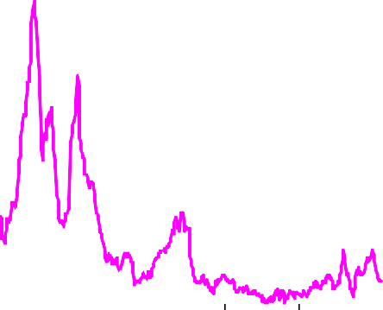

25

20

15

10

5

0

1972 1980 1988 1996 2004 2012

* 1. Retail Prices Index before 1976, Consumer Prices Index thereafter.

Source: ONS.

# Chart 4: The Taylor frontier

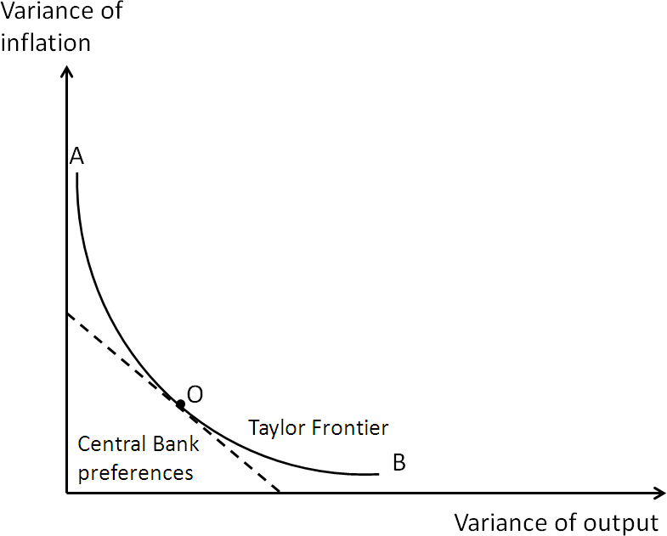

**Chart 5: The Minsky-Taylor frontier**

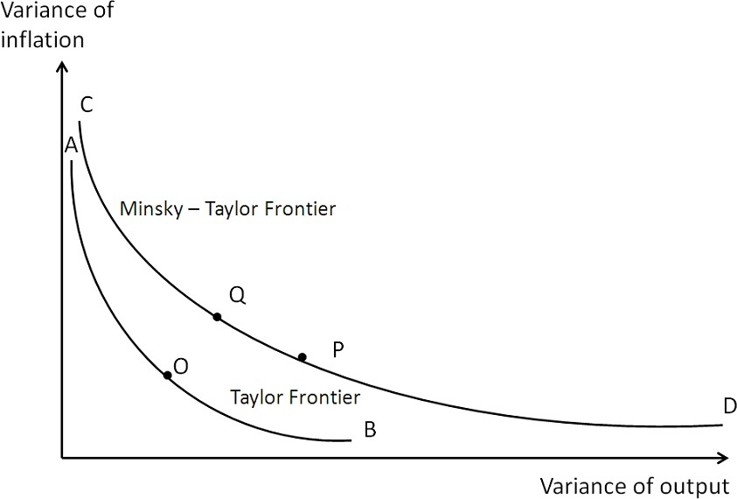

**Table 2: UK GDP growth rates**

|  |  |
| --- | --- |
|  | **Average annual growth** |
| **rate of GDP (%)(a)** |
| **1952 - 2012** | 2.6 |
| **1952 - 2007** | 2.8 |
| **2000 - 2007** | 2.9 |
| **2007 - 2012** | -0.5 |

1. Continuously compounded annual growth rates, calculated from the second quarter of the start year of each period to the second quarter of the end year of each period. Data for Q2 1952 interpolated from annual data.

Source: ONS, Bank of England calculations.

# Chart 6: Policy rates in the G7

Percent

8

6

4

2

0

1997 1999 2001 2003 2005 2007 2009 2011

UK US

Ja pan Canada

Euro area*

* Average of Germany, France and Italy prior to 1999

**Table 3: MPC voting statistics, 2000-2007**

|  |  |  |  |
| --- | --- | --- | --- |
| **Total votes** | | **Upside**  **dissent** | **Downside**  **dissent** |
| **2000** | 108 | 15 | 3 |
| **2001** | 117 | 4 | 18 |
| **2002** | 106 | 2 | 9 |
| **2003** | 108 | 8 | 13 |
| **2004** | 108 | 2 | 0 |
| **2005** | 108 | 10 | 7 |
| **2006** | 100 | 4 | 8 |
| **2007** | 108 | 8 | 11 |

Source: Bank of England, see [www.bankofengland.co.uk/monetarypolicy/Documents/mpcvoting.xls.](http://www.bankofengland.co.uk/monetarypolicy/Documents/mpcvoting.xls)

Source: Thomson Datastream.

# Chart 7: UK 5 year real interest rates, 5 years forward (a)

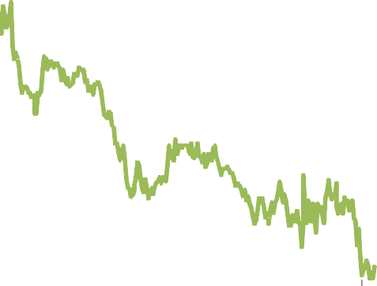

6

5

4

3

2

1

0

1992 1997 2002 2007 2012

* 1. Derived from the Bank’s government liability curves. Source: Bank of England.

# Table 4: Increase in major UK banks' assets, 2002-2007, £bn(a)

|  |  |  |  |
| --- | --- | --- | --- |
|  | **2002** | **2007** | **Change** |
| Lending to UK real economy | 682 | 1141 | 459 |
| Total assets | 1994 | 5511 | 3518 |

1. The banks included are: Alliance &Leicester, Barclays, Bradford & Bingley, HBOS, HSBC, Lloyds TSB, Northern Rock and RBS.

Source: Published accounts, Bank of England.

# Chart 8: The effect of an interest rate increase on the exchange rate

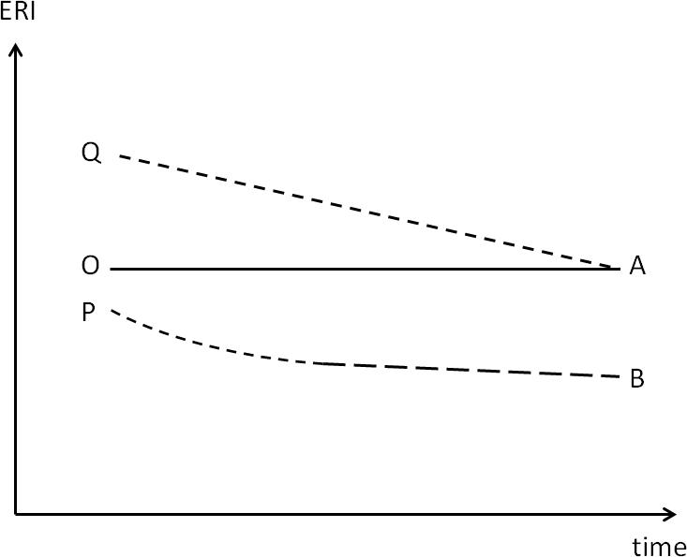

**Chart 9: UK banks’ leverage ratio (a)(b)**

Interquartile range

Median Ratio

60

50

40

30

20

10

0

1960 1970 1980 1990 2000 2010

* 1. Ratio of total assets to shareholder’s claims.
  2. The data are a backwardly consistent sample of institutions providing banking services in the United Kingdom in 2011. The sample includes the following financial groups: Barclays, HSBC, LBG, National Australia Bank, Nationwide, RBS and Santander UK. Where data are consistently available for the UK component of the banking group, these have been used. Northern Rock and Bradford & Bingley were included in the chart up to 2007 and 2008 respectively.

Sources: Published accounts and Bank of England calculations.

# References

Adrian, T and H. Shin (2011), “Financial Intermediaries and Monetary Economics”, *Handbook of Monetary Economics* 3A pp. 601-650, Elsevier.

Barker, K., (2003), “Adjusting to low inflation – issues for policy”, available at <http://www.bankofengland.co.uk/publications/Documents/speeches/2003/speech190.pdf>.

Barker, K., (2012), “Macroeconomic policy: too much autonomy and too little coordination”, Centreforum, available at [www.centreforum.org/assets/pubs/macroeconomic-policy.pdf](http://www.centreforum.org/assets/pubs/macroeconomic-policy.pdf) .

Bean, C., (2003), “Asset Prices, Financial Imbalances and Monetary Policy: Are Inflation Targets Enough?” in Anthony Richards and Timothy Robinson (eds.) *Asset Prices and Monetary Policy*, pp. 48‐76. Reserve Bank of Australia: Sydney.

Bean, C., M. Paustian, A. Penalver, and T. Taylor, (2010), “Monetary Policy after the Fall” In *Macroeconomic Challenges: The Decade Ahead*. Federal Reserve Bank of Kansas City.

Bernanke, B., (2011), “The Effects of the Great Recession on Central Bank Doctrine and Practice”, remarks at the 56th Economic Conference of the Federal Reserve Bank of Boston, 18 October 2011.

Bernanke, B., and M. Gertler, (1989) “Agency Costs, Net Worth, and Business Fluctuations”, *American Economic Review*, Vol. 79(1), pp. 14-31.

Bernanke, B., and M. Gertler, (1990), “Financial Fragility and Economic Performance”, *Quarterly Journal of Economics* 105, pp. 87-114.

Bernanke, B., M. Gertler, and S. Gilchrist (1999), “The Financial Accelerator in a Quantitative Business Cycle Framework”, in John B. Taylor and Michael Woodford (eds.) *Handbook of Macroeconomics, edition 1, volume 1*, pp. 1341‐1393. Elsevier: Amsterdam.

Borio, C. and H. Zhu (2008), “Capital regulation, risk-taking and monetary policy: a missing link in the transmission mechanism?” BIS Working Paper 268.

Brazier, A., R. Harrison, M. King, and A. Yates (2008), “The Danger of Inflating Expectations of Macroeconomic Stability: Heuristic Switching in an Overlapping‐Generations Monetary Model”, *International Journal of Central Banking*, 4(2), 219‐254.

Broadbent, B., (2012), “Deleveraging”, speech available at [www.bankofengland.co.uk/publications/Documents/speeches/2012/speech553.pdf.](http://www.bankofengland.co.uk/publications/Documents/speeches/2012/speech553.pdf)

Caballero, R., (2010), “Macroeconomics after the Crisis: Time to Deal with the Pretense-of-Knowledge Syndrome”, *MIT Department of Economics Working Paper* No. 10-16.

Curdia, V., and M. Woodford, “Credit Frictions and Optimal Monetary Policy,” working paper, Federal Reserve Bank of New York, August 2009.

Eichengreen, B., M. El-Erian, A. Fraga, T. Ito, J. Pisani-Ferry, E. Prasad, R. Rajan, M. Ramos, C. Reinhart,

H. Rey, D. Rodrik, K. Rogoff, H. Shin, A. Velasco, B, Weder di Mauro, and Y. Yu (2011), “Rethinking Central Banking,” Brookings Institution, Washington.

Eggertsson, G., P. Krugman “Debt, Deleveraging, and the Liquidity Trap: A Fisher-Minsky-Koo Approach”,

*The Quarterly Journal of Economics (2012) 127(3): 1469-1513.*

Fisher, I., (1933), “The Debt-Deflation Theory of Great Depressions,” *Econometrica*, Vol. 1, no. 4.

Geanakoplos, J., (2010), “The Leverage Cycle.” In D. Acemoglu, K. Rogoff, and M. Woodford, eds., *NBER Macroeconomics Annual 2009*, vol. 24, 1-65. Chicago: University of Chicago Press.

Gertler, M., and Kiyotaki, N., (2010), “Financial intermediation and credit policy in business cycle analysis”, in

*Handbook of Monetary Economics*, Vol. 3A, Amsterdam: Elsevier.

Issing, O., (2012), “Central Banks – Paradise Lost” Mayekawa Lecture, Institute of Monetary and Economic Studies, Bank of Japan, Tokyo, mimeo.

King, M., (1994), “Debt deflation: theory and evidence,” *European Economic Review*, Vol. 38, issue 3-4, pp 419-45.

King, M., (1999), “Challenges for Monetary Policy,” in *New Challenges for Monetary Policy*, 11‐58. Federal Reserve Bank of Kansas: Kansas City.

King, M., (2000), “Balancing the Economic See-Saw,” speech available at [www.bankofengland.co.uk/publications/Pages/speeches/2000/speech82.aspx.](http://www.bankofengland.co.uk/publications/Pages/speeches/2000/speech82.aspx)

King, M., (2002), “Monetary Policy in the UK: - challenges ahead,” speech available at [www.bankofengland.co.uk/publications/Documents/speeches/2002/speech169.pdf.](http://www.bankofengland.co.uk/publications/Documents/speeches/2002/speech169.pdf)

King, M., (2003), speech in Leicester available at [www.bankofengland.co.uk/publications/Documents/speeches/2003/speech204.pdf.](http://www.bankofengland.co.uk/publications/Documents/speeches/2003/speech204.pdf)

Kiyotaki, N., and J. Moore, (1997), “Credit Cycles”, *Journal of Political Economy* 105(2).

Large, A., (2005), “Monetary Policy: Significant Issues of Today”, speech available at [www.bankofengland.co.uk/publications/Documents/speeches/2005/speech262.pdf.](http://www.bankofengland.co.uk/publications/Documents/speeches/2005/speech262.pdf)

Leigh-Pemberton, R., (1992), “The Case for Price Stability”, *Bank of England Quarterly Bulletin*, November.

Minsky, H., (1982a), “Debt-Deflation Processes in Today’s Institutional Environment,” *Banca Nazionale del Lavoro Quarterly Review*, December.

Minsky, H., (1982b), “The Financial‐Instability Hypothesis: Capitalist Processes and the Behavior of the Economy” in Charles Kindleberger and Jean‐Pierre Laffargue (eds.), *Financial Crises*. Cambridge University Press: Cambridge.

Rajan, R., (2005), “Has Financial Development Made the World Riskier?” in *The Greenspan Era: Lessons for the Future*, pp313-370. Federal Reserve Bank of Kansas City: Kansas City.

Reinhart, C., and K. Rogoff, (2009), “*This Time is Different: Eight Centuries of Financial Folly,”* Princeton University Press.

Rotemberg, J., and M. Woodford, (1997), “An Optimization-Based Econometric Framework for the Evaluation of Monetary Policy”, *NBER Macroeconomics Annual*, Vol. 12, pp. 297-346.

Shirakawa, M., (2010) “Revisiting the Philosophy behind Central Bank Policy”, Speech at the Economic Club of New York, April 22 2010.

Taleb, N., (2012), “Antifragile: Things That Gain from Disorder” Forthcoming from Random House (US) & Penguin (UK).

Woodford, M., (2003), “Interest and Prices: Foundations of a Theory of Monetary Policy,” Princeton University Press: Princeton, NJ.